**Manual for Parallel Computing in Python**

Introduction

The ability to parallelize code has become a necessary tool to any aspiring developer due to the rapid increase of multicore processors. This manual seeks to convey the knowledge of how to utilize parallel programming using the standard Python 3.9 modules. Parallel computing or parallel programming is a type of computing architecture in which several processors execute an application or computation simultaneously. This “parallelizing” of the code allows for more complex applications and/or a greater amount of computational power than can be accomplished with a single thread of code execution.

**SECTION 2: DETAIL ABOUT THREADS, PROCESSES. WHO IS INTENDED AUDIENCE**

Intended Audience

This manual assumes that the reader has prior programming experience and a familiarity with Python. Having said this, there are some topics that should be summarized before beginning with the procedure. To reiterate, parallel computing is a type of programming that utilizes multiple sequences of code execution simultaneously to perform more machine instructions. In regards to this text, a thread is a single sequence of instructions that can be managed independently. The majority of projects that a beginning programmer studies are done with a single thread and can be considered serial programs. In addition to this, a process is an instance that is being executed by one or more threads. Multi-processing, is as its name implies, the ability to access multiple processes each with their own supply of threads to execute instructions within an application. With this knowledge, the progression from lowest complexity to highest for parallel programming is: serial process, multi-threaded process, multi-process application.

NOTE: (Add section about GIL here?)

**SECTION 3: PROCEDURE FOR PARALLELIZING CODE**

Preface

This section will go into detail on a general approach to parallelizing an I/O bound or CPU bound process using Python and its standard modules. The examples used may have modules that are not included with the current version of Python (Python 3.9.0) used by this manual. This text will include one example of an I/O bound process and one example of a CPU bound process.

1. To begin parallelizing I/O and CPU bound programs, first determine the “driver” function. This “driver” function is the function that will be performing the specific instructions that is to be parallelized. This function typically will be called many times by the program.
2. Once the driver function is determined, the input that is fed to function must be processed. The data must be partitioned correctly in order for the code to be parallelized correctly. The easiest way to accomplish this is to create a list object with all of the data stored inside.
3. After the list object is created, begin operating over the list object with a simple for loop which will pass this data into the appropriate thread or process object which will parallelize the program.

**Example of Multithreading (CPU bound process):**

This program’s purpose is to encrypt a list of strings.

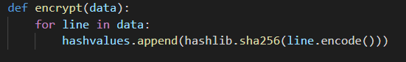

The list of strings is formed from a text file located within the same directory as the script. This list must then be split into a list of chunks. Each chunk can be fed to the appropriate thread for encryption.

The threads are stored into a list and then are then iterated over using a for loop as shown below. In the context of this program, the number of threads is equal to the number of cores on the CPU.

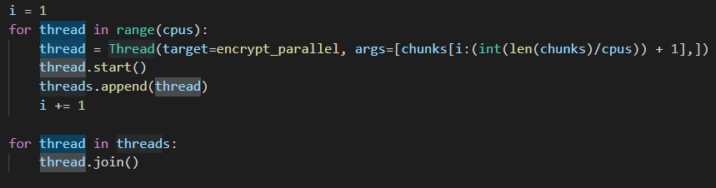

**Example of Multithreading #2(CPU bound process):**

This example displays another method for parallelizing the same script using a Thread pool.

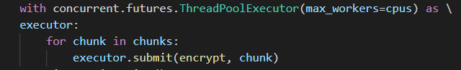

**Threads vs Processes in Python:**

**Example of Multiprocessing (I/O bound process):**

This program’s purpose is to download a series of text files from the U.S. Securities and Exchange Commission. It accomplishes this by parsing through the HTML code of the given URL and building a list of string objects named “links” which is filled with the URLs of all of the subdirectories contained within. This is implemented by a function named “parseDirectory” which takes a list for its single argument.

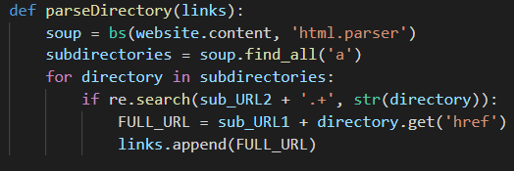

This list of links is then passed into the driver function named “download”.

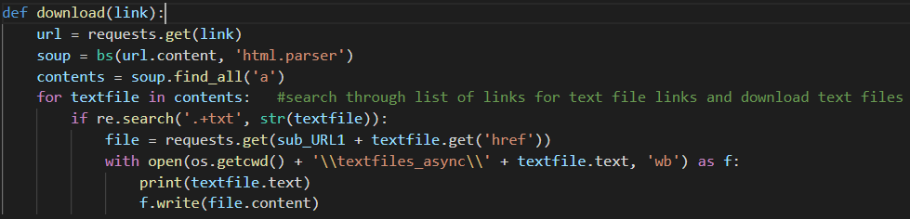

This function takes in a singular link (string) as its argument in order to coordinate with Python’s process pool executor.

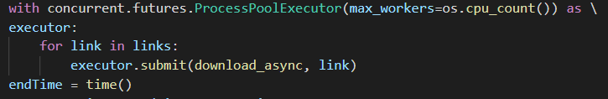

**Example of Multiprocessing #2 (CPU Bound Process):**

This program uses multiprocessing to calculate and determine prime numbers and then append those numbers to a list.

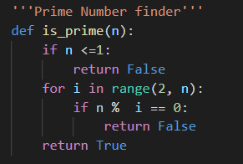

It uses a simple algorithm to determine if the given number is prime or not.

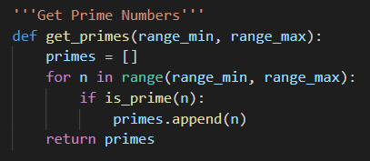

This function is used to find all of the prime numbers within a given range of numbers and appends them to a list.

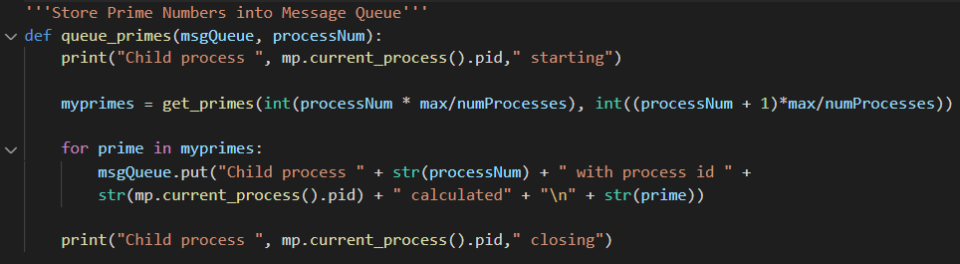

This is the driver function for this program. It creates a list using the get_primes function and then places each of those prime numbers into a queue which will be accessed by the specific process that is calling this function at the time.

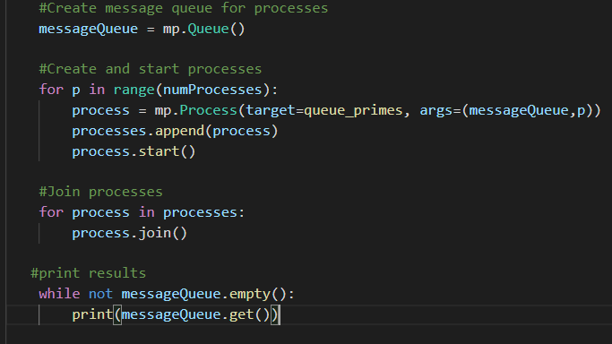

This is the main function for this program. It creates a queue using the multiprocessing module and then creates the processes that will be used to queue the primes. Once a process is created, it is appended to a list and then the process is started. Then we join each of the processes using the built in join function.

**SECTION 4: CONCLUSION**

Parallel computing, when done correctly, can be a gamechanger for any developer looking to add to their skillset. This manual covered only a fraction of potential methods that can be used for parallelizing the Python code. For any additional details regarding some of the material used in the manual, please see the attached appendix.

Appendix